A Brief History!

A note from
Friern Barnet Community Library;

FBCL Would Like To Thank;

‘Dorrell Dressekie’
Friern Barnet & District Local History Society
for providing us with this copy of his work. More details at the end of this document.

In this writing; you could find interesting facts, such as;
- The very first book [The Story of San Michele] taken out from this library in 1934,
- The background, People & services like lending up to 700 books daily!
- The script of the library-opening-prayer!
- The Local people, closure, campaign
- The opening of Friern Barnet Community Library.

Please Note;
There are some Converted-Typo-Errors as this is an old document now converted in a digital format, and technology is not perfect! Below you may see some inappropriate ‘8’ so; consider it ‘g’ (!!). We hope you find this history fascinating! FBCL ( March.2019. F.I.)

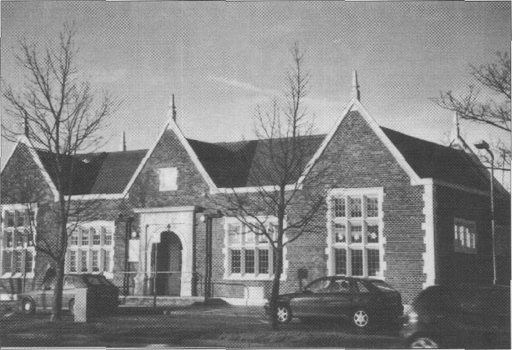

Frìern Barnet district Local History Society
This history was compiled and written by Dorrell Dressekie in 2010

and updated in June 2012

Background
Friem Barnet Library, housed in a Tudor style building in Friern Barnet Road, was opened in 1934 by the Middlesex County Council Library Service. A purpose•built a library, it was among the first to be built and filled out under the County Scheme for whole-time lending libraries. Other whole-time lending libraries of the period under the Scheme were Uxbridge (1930), Y iewsley (1931 ) and Hayts (1933).

Before the opening of the label, Friem Banner Urban District Council had quite a different procedure for the lending of books. Books were bought and stood in school rooms and in church hall cupboards and the lending was done by volunteers, mainly teachers. They managed the service from the qaite cramped confines of their school rooms, with opening times varying from one tn two hours once or twin a need.

The Public Lib tries Act 1919 signalled significant changes for library services. Middlesex County Council, as ltte Authority under the Act with responsibility for library services in its education area, inaugurated the County Library Service and with the Education Authority, set up a sub-committee to consume on the provision of libraries. The outcome of the consultation was th scheme to provide libraries in the district too small to maintain their own library service, and where those districts, in further consultation, showed interest in such a scheme.

_______________________
Development of Friern Barnet Libraries
The population the estimate for Friem Barnet then was I S,8 l8 and interns( in rhe County Council Scheme led to a meeting with representatives from the Middlesex Count Council Library Service to discuss ihe formation of a local branch. Friem Barnet Libre Committee was inaugurated and talks began on how to sdopt the scheme in the district

The Local Library Committee acted promptly wiih a request to Friern Barnet Urban District Council to allow space ai the Council Offices, The Priory, for use as a library. A room was a{locnted, furniture and equipment put in place and contact made with the Middlesex County Librarian for the supply of books.

An honorary librarian was en-opted from the County Library aft4, according to records, a I ibrary of 1,200 volumes opened on 10 December 1923 in The Priory, which was si* •*
at the cnrner of Friern 8arnet Lane arid Fenn 8amet Reed. Opening sessions in chc public were for two hours, 7pni to 9pm, every Monday evening. the service proved to be in great demand. The number of borrowers increased rapidly as did the numher of books borrowed. This led the Library Committee tn request permission from the Urban District Council to allow more opening sessions. Tuesday evening sessit›ns were introduced and were soon fol lowed by Wednesday and Friday afiernoons, 2.30 to 4pm. The librarian was assisted by volunteers from the local community .

At the thifd Annuel General Meeting of fhe Library Commince in December 1926, the librarian reported an increase in membership, with 368 new members in the year under review. ,374 boos were in circulation and the largest number of books exchanged in one session was 675. The rcpresenu‹tive of the County Library Service present et the meeting commented favourably on the work of lJte library and added special compliments to the efTous of the librarian and the local volunteers

“0 God, who in Thy Fatherly care for human need, has appointed hours of se‹viw as wel) aS hours of work; bless we beseech Thee, tTtis endeavour t¢t provide opportunity for research and recreation to people of this place; and grant thai the minds of all who frequent this library may be enlightened by the things that they read and study, to the Glory of Thy Name, to public benefit, and their own eternal good; through Jesus Christ Out Lord. Amen"
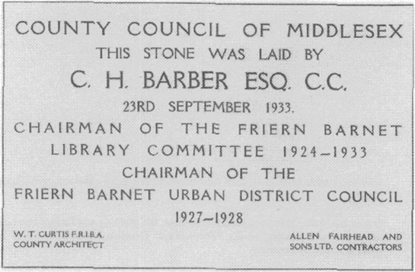

be occasion concluded with guests moving on to a manjuee on the lawn in rhe gmunds of The Priory where tea was served.

The opening
In the following year, rim Friday 23 March 1934, the Friem Barnet Branch Library opened to the public. The opening ceremony, Retd in the presence of a large and distinguished gathering, was «haired by County Alderman Hi S Button, JP and Chairman of Middlesex County Council, and the library was declared open by Lord Elgin, Garl of Elgin and Kincardine, Chairman of the United Kingdom Carnegie Trust, an organisation promoting the development of rural libraries.

The full descriptive note of the Friern Barnet Branch of the Middlesex Counly Libraries prepared for the opening ceremony was read by Mr C H Barber:

The library building is planned to accommodate a lending section, a reference section, a read: rig mm and a librarian’s room. The lending section is designed on the ”open access" system and this portion, in common with the remainder of the building, is capable of comp\e‹e supervision from the librarian’s desk, which is centrally pTacs4.

The building is designed in the Tudor style, the exterior being faced with multi-
red facing bricks with stone quoins, mullions, transoms, etc. The roof is covered

The first book issued from the new library was a copy o I Story of San Michele by Alec Munthe. The borrower was Mr A C Henry, Chaionan of the Priern Barnet Urban District Council and the book was issued to him by Lord Elgin. 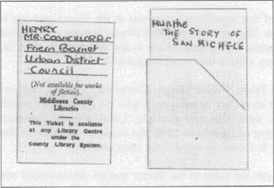

The new library marked a significant development in the County Council Library Service and soon became a pivot for ihe local community. The stock of books on the opening was 8,060 classified under the headings of non-fiction, fiction and children.

Opening hours were l0am to 9pm, so planned in order to allow extra time fur people returning home after their day's work. Pupils attending local schools were allocated a special section within the library and tor younger chillier there were afternoon sessions of two hours from 4.20pm tn 6.30pm. except on Saturdays. The lemporary libraries at The Priory, Holly Part School and St James School were subsequently closed.
By the end of the first year of opening the daily average issue of books was as much as 502 and recorded as frequently rising to 700. Middlesex County Council Annual Report, 1934 to 1935, noted ihe increase in book stock and gosh in the number of registered borrowers and commcut6 or the performance of Frien Barnet Branch Libras as “providing a service equal to any in the County."

heading Library's 2 I Birthday. The distinguished gathering included representatives of Middlesex County Council, Friem Barnet Urban District Council, some local organisations and some of the guests who had attended the opening ceremony in 1934. Chief among them was the Earl of Elgin, who had travelled from his borne in Scotland for this occasion, saying on acceptance of ihe invitation: One always a etc an encore.
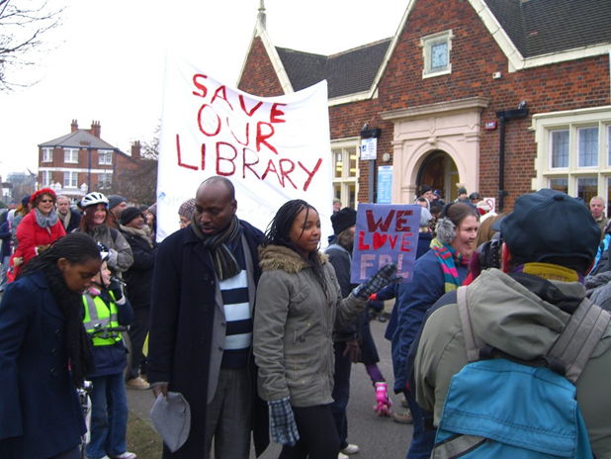
The Chairman of Friem Banner Urhan District Council in 1934, Councillor A C Barber, who had borrowed the first book, announced to the guests that he stiff bad the book in his possession- Middlesex County Council Library Service had done a special binding of the book and had presented it to him as a memento.

The Librarian 8nd her staff at Film Banner were credited with their professionalism and them was a special mention for the project they had pioneered which was to allow borrowers free access io bookshelves to select their books. That had prove4 quite significant nationally and gained so much popularity thal it was copied ipj¢matinnnl{y.
Excellence
members of Friern Barnet Libs could, for example, borrow books from Ie North
Finchley branch in Ravensdale Avenue.

RBOrganlaatlDn
The County of Middlesex disappeared in 1 965 due to boundary changes and Friem Barnet Urban District, along with the local authorities of Fin ^7. Hendon, Barnet and East Barnet, became the London Borough of Barnet. Barrier Council Library Service then came into operation and, working closely wih the Education Department and the

Borough Librarian, rook on the responsibility of all libraries in the Borough,

Friem Barnet Library, under the County Library Service, continued iis valua6le work catering for the enjoyment of its community and expanding its services io meet the changing needs and demands of iis users. Special Children’s and Teenage sections were added, class visits by children from Holly Park and St John’s Schools were encouraged and for very young children there were Story Time sessions. There was a choice of audiobooks, videos and large print books and a range of leaflets and pamphlets with information on various community activities. Some equipment, suCh as small chairs and loys for the children’s area, were provided by the Friends of Barnet Borough Libraries.

The Friends of Barnet Borough Libraries was founded in 1988 by Councillor Frank Gibson, onetime Mayor of the London Borough of Barnet, to create community awareness and support for 8amet Libraries. A non-political 8roup ot’ library users, the Friends worked throu8h a central commitlee and over the years raised funds tn supply extra amenities such a s coffee machines and to assist with some library activities. Members of the Friends were present in 1994 to join stab of Friem Barnet Libs in celebration of what was defined as ihc “pensionable age" of the library, its 60" year since
opening. Children from Friem Bac«et schools took part in the celebration with craft
7

The excellence of the library was without doubt as was evident in an exhaustive inspection of all Barnet libraries by the Audit Commission in 2001 , resulting in a throe star rating, ihe highest award for excellence. The Audit Commission Report stated then:

The services have good irack record of delivery and responding to users' demands. Staff and users share a strong commitment to improve the

The library offered more than a book lending service. Library stock included CDs, DVDs, large print books and items in some community languages. There was a range of pamphlets, magazines, trade journals and some new publications that were an added attraction. User had access to computers, iniemei access and info•link helpline and trained and experienced staff helped everyone to make the heat use of the facilities.

Local councillors held surgeries at set times in the library; there were monthly coffee mornings with speakers, always on a topic of interest. The very Voting and their parents had Rhyme Time sessions and children from nearby St John’s School, who themselves used the library, were the carol singers at Christmas lime. On a wider front, the library provided the setting fot a design project for some forty student from Middlesex University preparing fot Level 2 in Interior Design. The students wete provided with a set of drawings of the building and allowed access, usually in pairs, for a period of the project.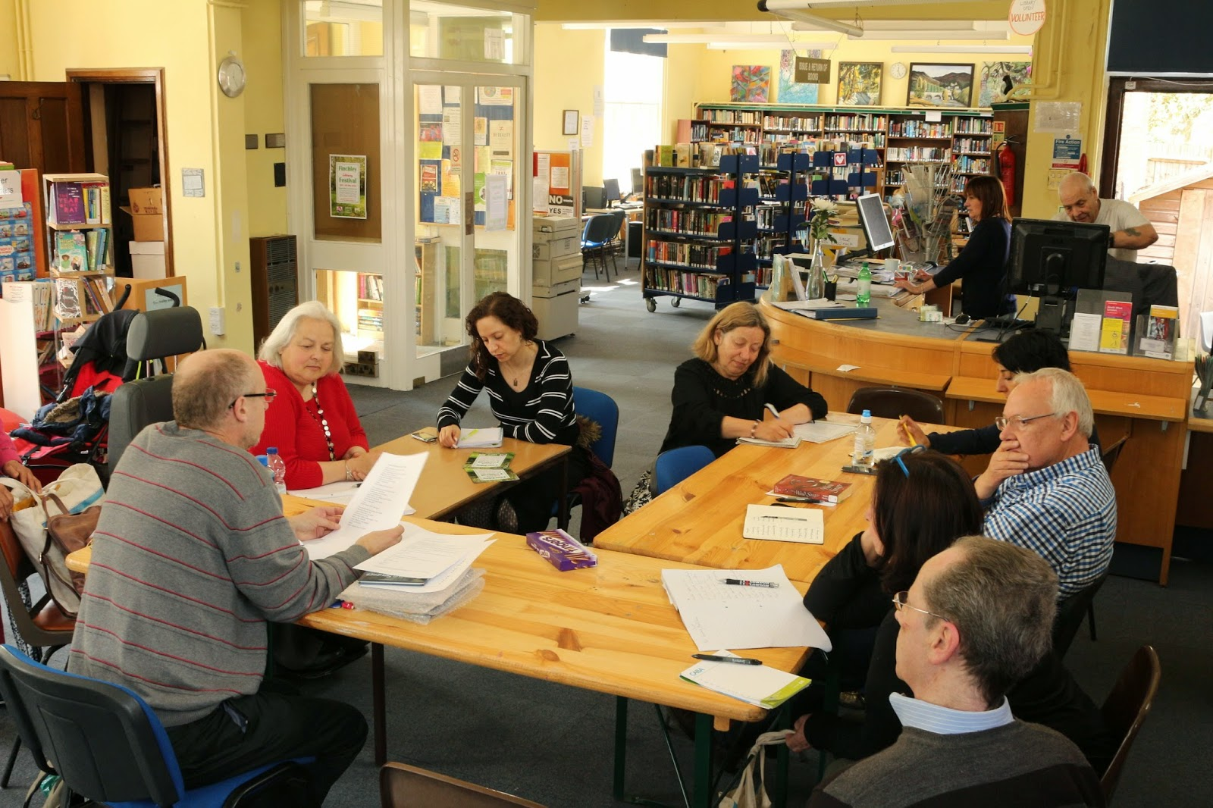
Oesc7iptJc'n c'f the Libras as recorded for the students on the shalt of their project stated: This single storey building is located at N 11 3DS and sits north of Friern Barnet
The road on an open green site of jusi under 2000 square metres. The building basa pass footprint area of 220 square metres and a net area of 192 square metres. The building's principal facade faces south and has distinctive large windows lh8t offer good light to the main spaces and are about 4.74m high. The building is set back from the main road and a slip road enters the site thai provides parking. To the west of the building is an open green space that faces south and St John’s parish church."

As pan of Barnet Libraries’ Family Learning Festival in October 2009, Fiiem 8amet Library participated with a teaming session tiiled We6site for Under Fives. Paints were invited with their children to participate in internet activities and looked at a range of sires for under fives including reading, music and art, by the A priest outside the library oy 21 May 2011.

The People's Library
Closure of the library was a disappointing outcome lot campaigners and for the community in general. But “Save Friern Barnet Library" Group and its supporters had no intention to walk away ai what seemed be final chapter. The plan to continue the campaign by setting up a pop-up library service, dubbed the People’s Library was almost
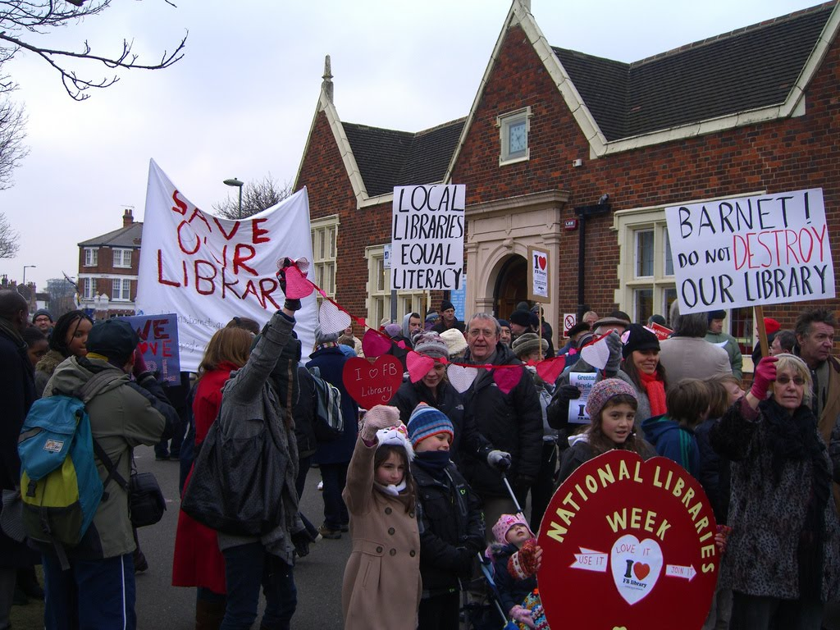
spontaneous.

On Saturday 14 April 2012, start day for the People’s Library, local residents of all ages gathered on the green by the locked Friem Barnet Library for the beginning of this new chapter. Many volunteers were on hand to put up marquees and le6les and assist generally. The large numbers of books on display were soon to have labels in the front covers: ‘ Friern Barnet People’s Library’ and set out in of of fiction, nonfiction, children’s books, and specialist subjects.

One local newspaper, The Times Series, Thursday April 19“ reporting on the event under the heading ‘Another dB\. ncW chapter', noted the large gathering that turnout out to support the People’s Library.

The ongoing determination by \c›csI residents to continue their campaign through the People’s Library has been gaining support from a range of sources. The public service union, Unison, for example, which supported the campaign to protect libraries, had its representative on the green. Visits from Banner Councilors do happen on occasion and, in a way confirmed the clear cross-party support for the residents’ views. The Royal British

This history was compiled and written by Dorrell Dressekie in 2010. and updated in June 2012 Friern Barnet gE District loca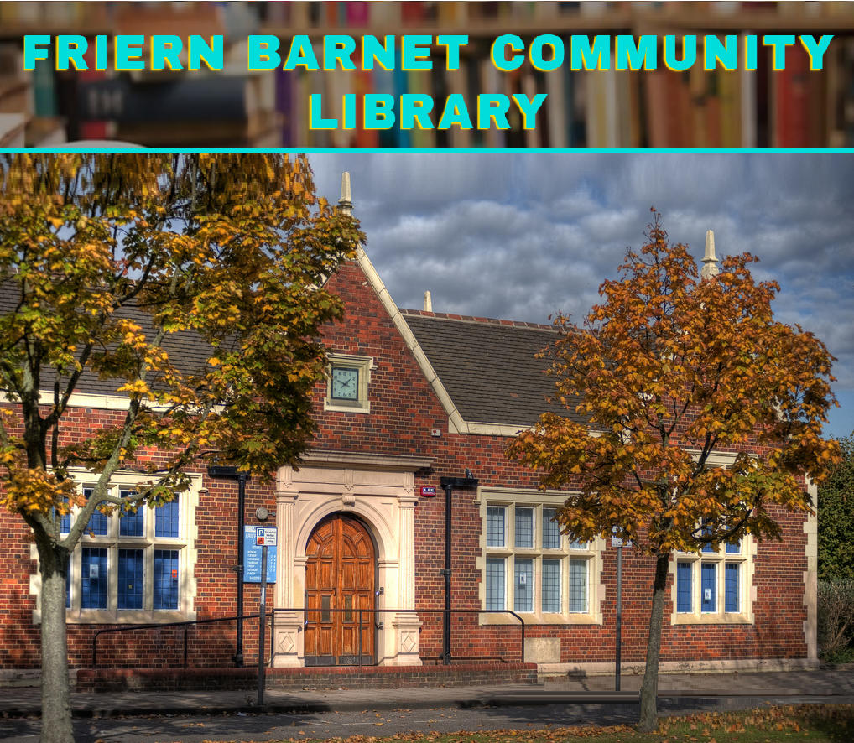l History Society 2O12

Friern Barnet @ District Local History Society
email: fnembarnethistory@hotmail.co.uk website: friernbarnethiatory.org.uk photographic website: www.friern-barnet.com
FBCL Library’s Website; https://fbclibrary.org/ {March.2019 -- by F.I. FBCL} https://fbclibrary.org/2019/03/21/history-of-friern-barnet-community-library/

